**PERSONAL BLOG ON IBM CLOUD STATIC WEB APPS**

**Phase 2 Submission Document**

|  |  |
| --- | --- |
| NAME | Krishnaraj K |
| TEAM ID | 8935 |
| TEAM NAME | Proj_207157_Team_2 |
| PROJECT NAME | 8301-Personal Blog on IBM Cloud Static Web Apps |
| SUBMISSION DATE | 10-10-2023 |

**Introduction**

In this phase, we'll explore exciting ways to elevate our travel blog and boost user engagement. These innovative features will not only captivate our audience but also foster a sense of community among fellow travelers.

**1. Social Media Sharing Buttons**

Amplify Your Reach

Integrate social media sharing buttons into our blog, allowing readers to effortlessly share our captivating content on their favorite platforms. By selecting the right social networks, we'll expand our blog's influence and inspire more wanderlust.

**2. Interactive Maps**

Bring Your Adventures to Life

Enhance oour blog with interactive maps that showcase the destinations we've explored. Utilize services like Google Maps or Mapbox to pinpoint locations, add brief descriptions, and link to related blog posts. Ensure a seamless map experience across all devices.

**3. Comment Sections**

Spark Conversations

Create an inviting space for reader interaction by incorporating comment sections at the end of our blog posts. By integrating this section,the user can easily get more information regarding.A better information provided,better will be the results.Choosing a user-friendly commenting system and implement tools for spam filtering and moderation can maintain a positive and engaging atmosphere.

**4.Testimonials**

Voices of Praise

Our travel blog website is enriched with authentic testimonials from avid travelers who have found inspiration, guidance, and unique experiences through our platform. These testimonials serve as a testament to the valuable insights and recommendations we provide, showcasing the real impact of our content on travelers' journeys.

**5.Feedback and Support Channels**

Your Feedback matters

Provide clear contact information and support channels for users to reach out with questions or issues.Offer a chatbot or live chat for real-time assistance.Feedback helps us understand our preferences and interests, allowing us to curate content that resonates with us. Whether we're passionate about adventure travel, culinary delights, or cultural experiences, our input ensures us provide content that's relevant and engaging.

**Flow chart representation**

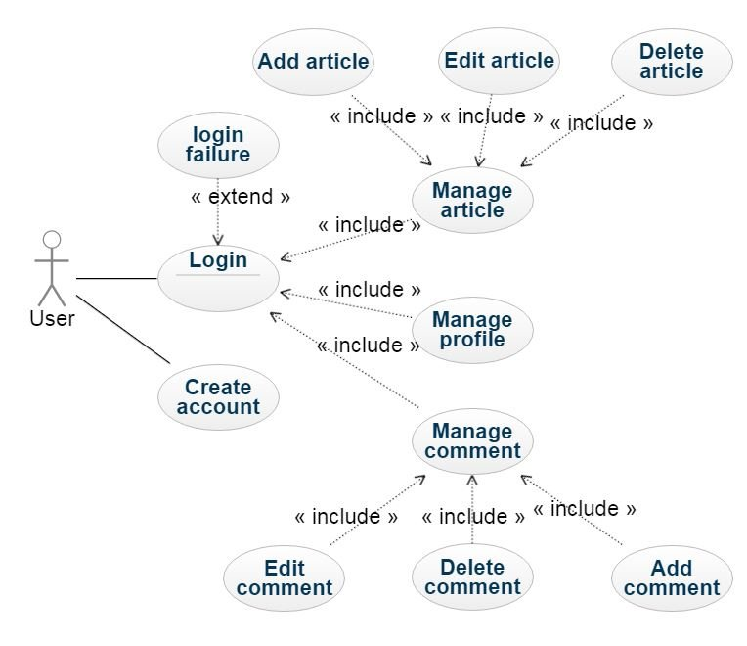

**Conclusion**

We have explored innovative ways to enhance user engagement and interaction on a travel blog website. We proposed integrating social media sharing buttons, interactive maps, and comment sections to achieve this goal.It highlights the significance of these design innovations in achieving the blog's mission of inspiring and connecting travelers. It emphasizes the commitment to user-centered design, ongoing improvement, and the invaluable role of user feedback in shaping the travel community.